# LINUX PROJECT

**OBJECTIVE:**

This project shows a details log of client (User) authentication. During SSH login and server administrator can easily find out valid and invalid user.

# TECHNOLOGY:

* Linux Basic Command
* IP Authentication
* SSH Configuration
* Monitoring Log

# DEVICE:

* + 2 Computers
    - SERVER PC or CLIENT PC

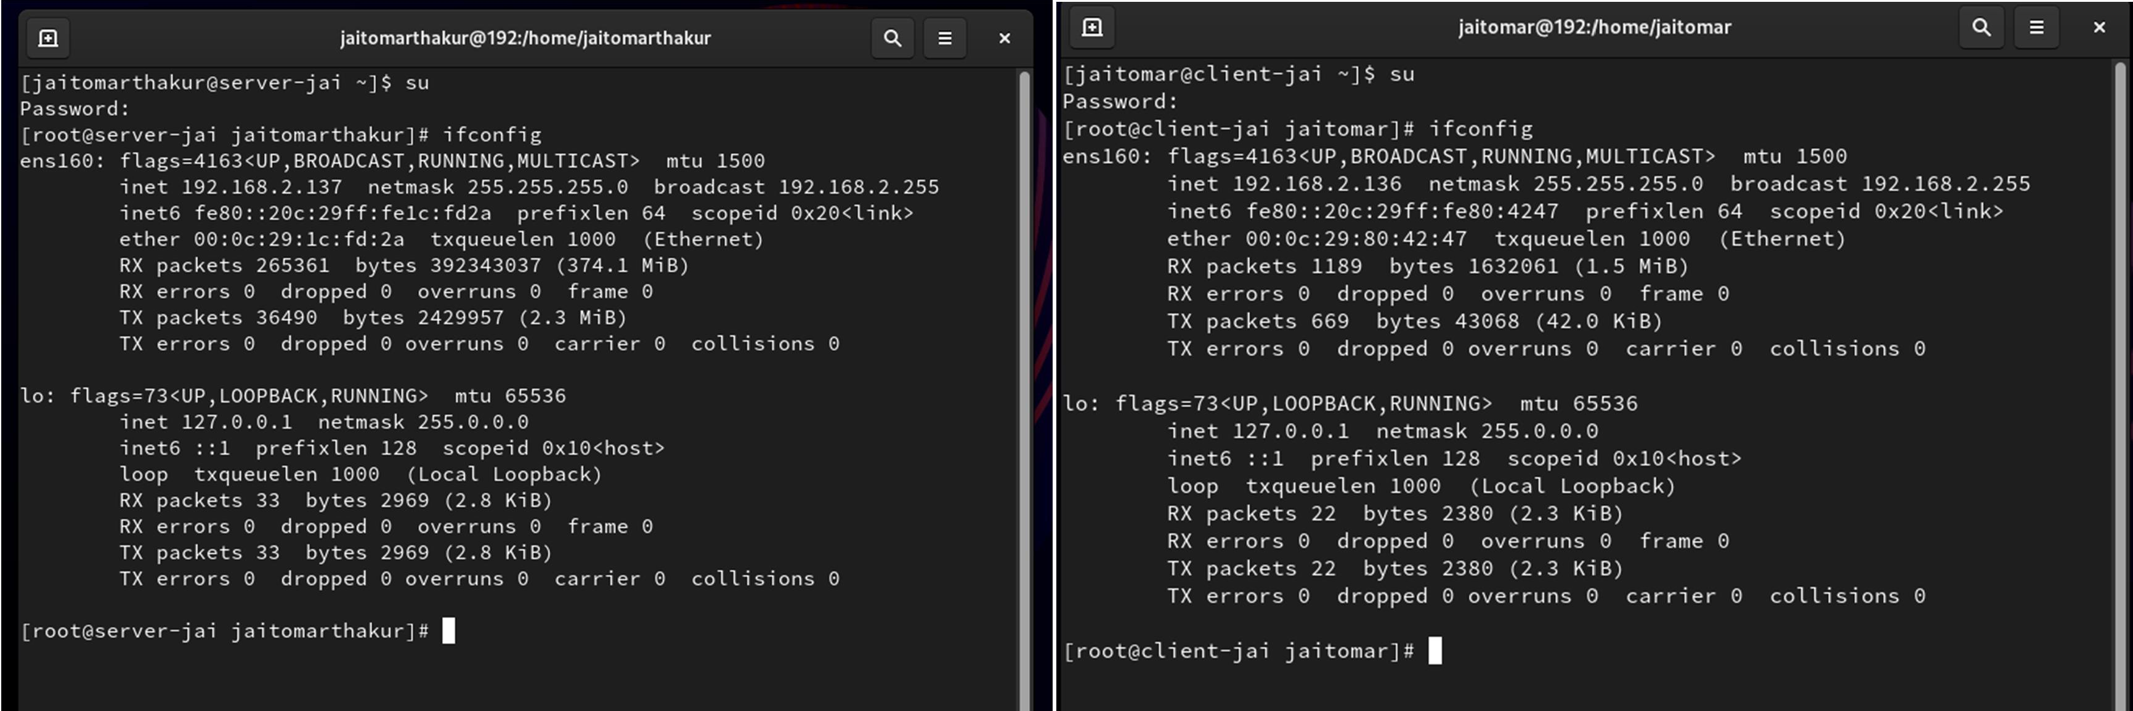

Hostname on server machine Hostname on client machine

# PROCEDURE:

We have two machines, one server machine and one client machine.

## Step 1 –

Now, check the Ip of both machines (ifconfig) and try to ping one another.

Let, IP of server machine = 192.168.2.137 and IP of client machine = 192.168.2.136

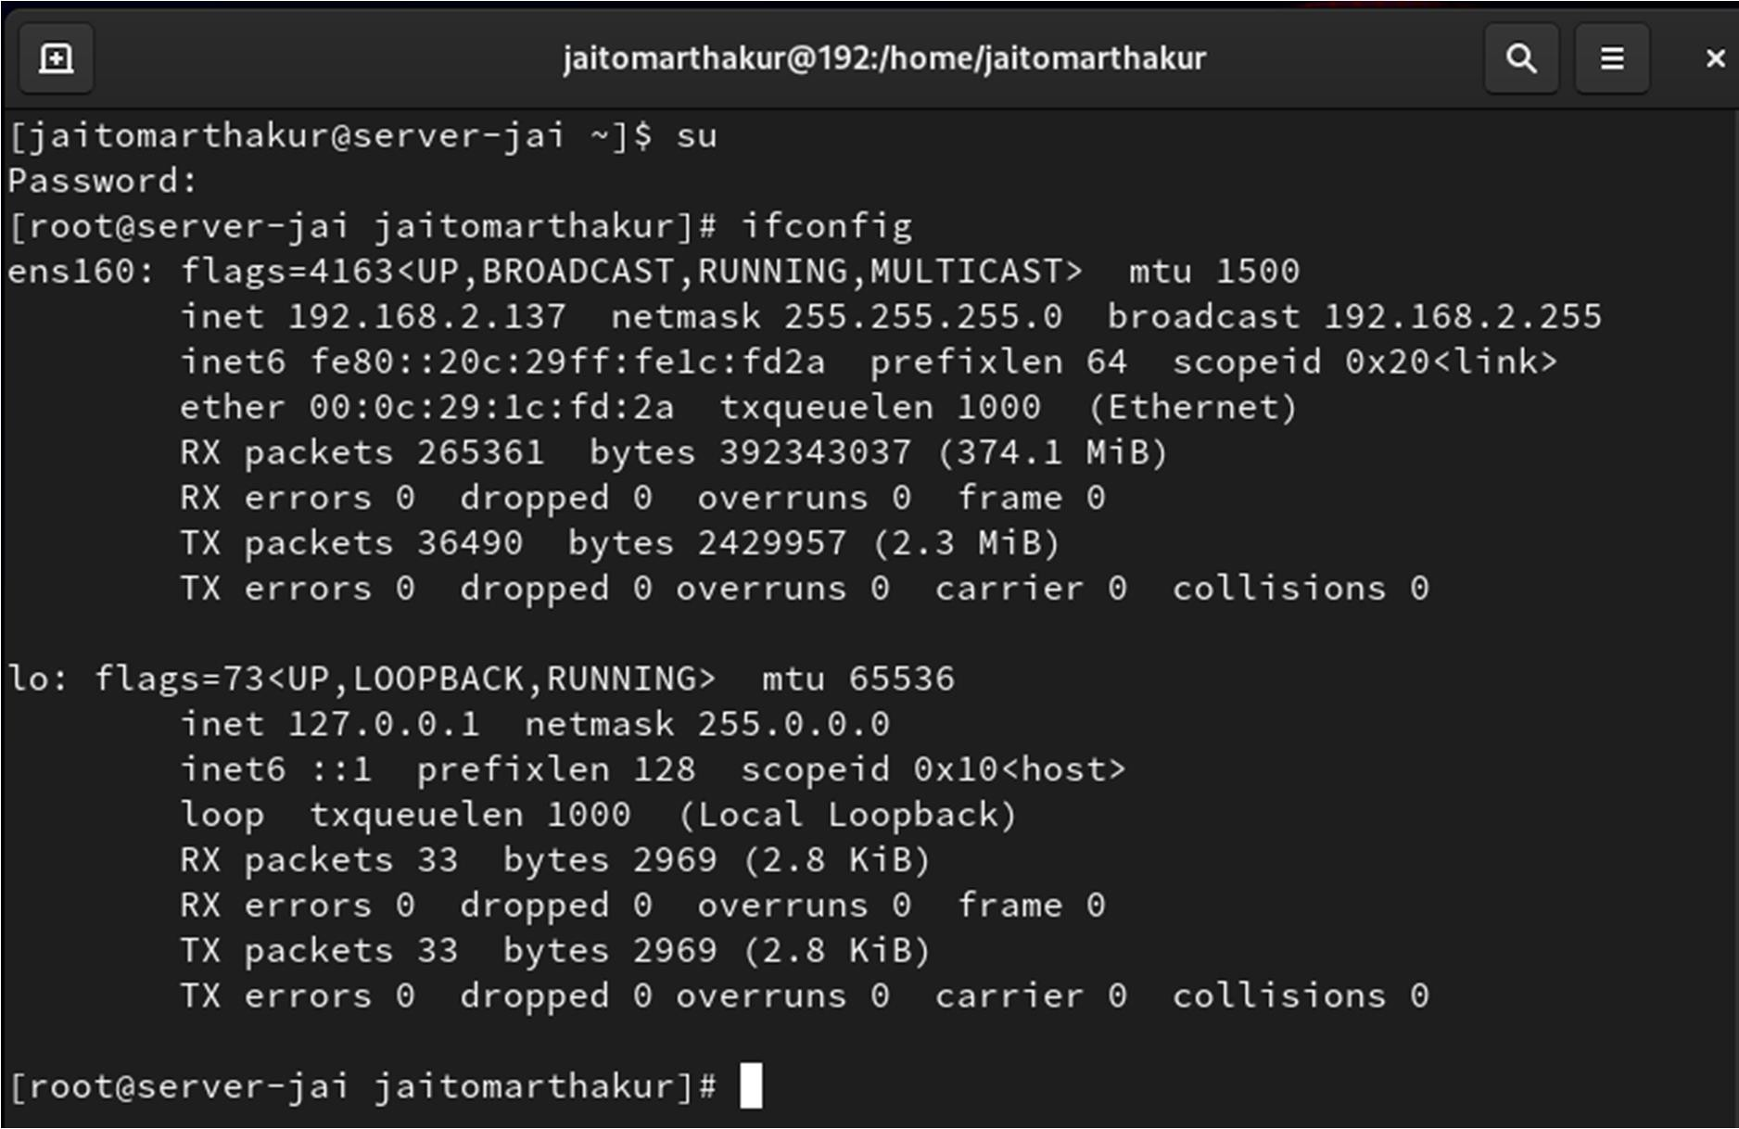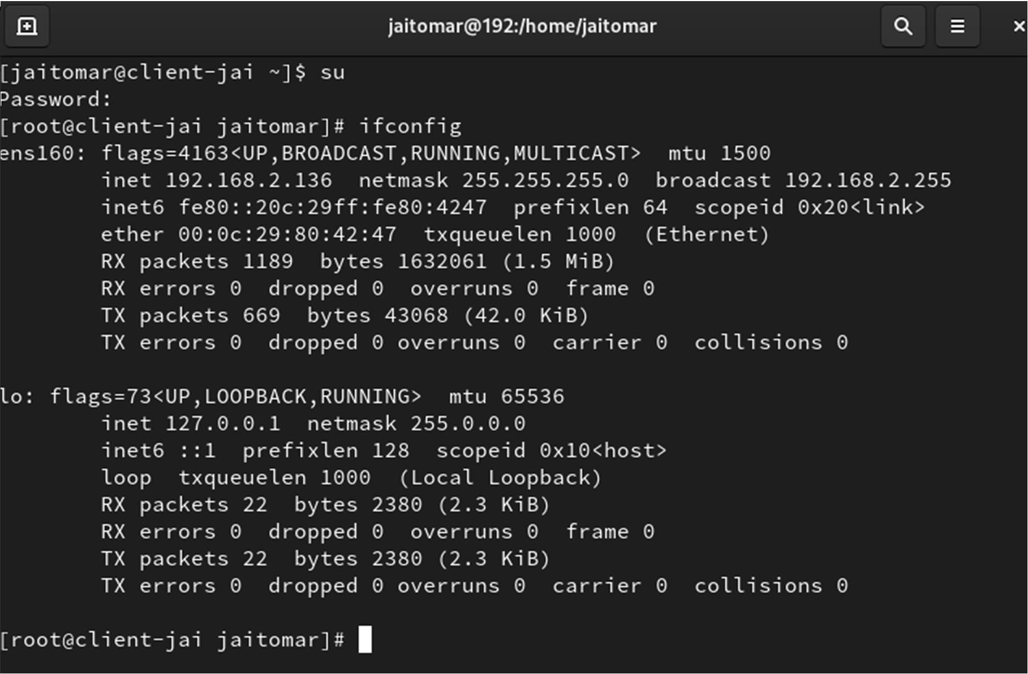

IP on Server Machine = 192.168.2.137 IP on Client Machine = 192.168.2.136

Now, check ping (ping_ip ).

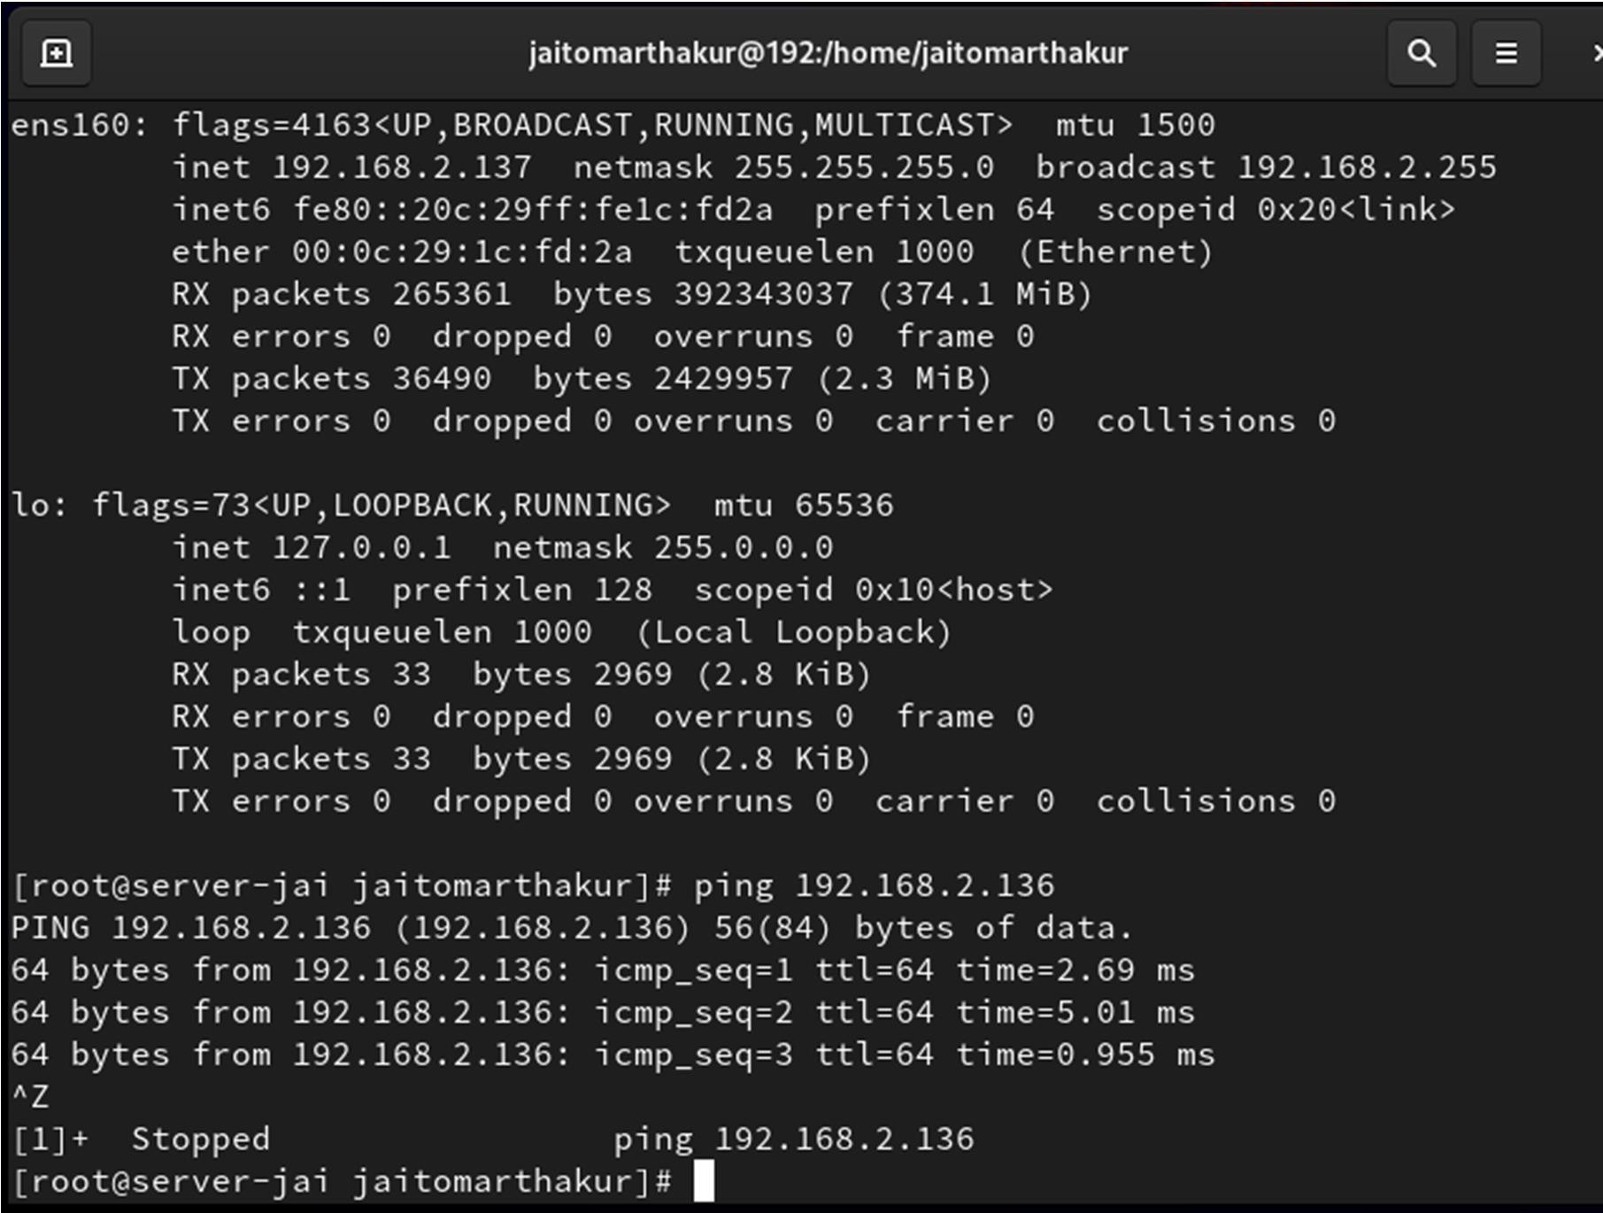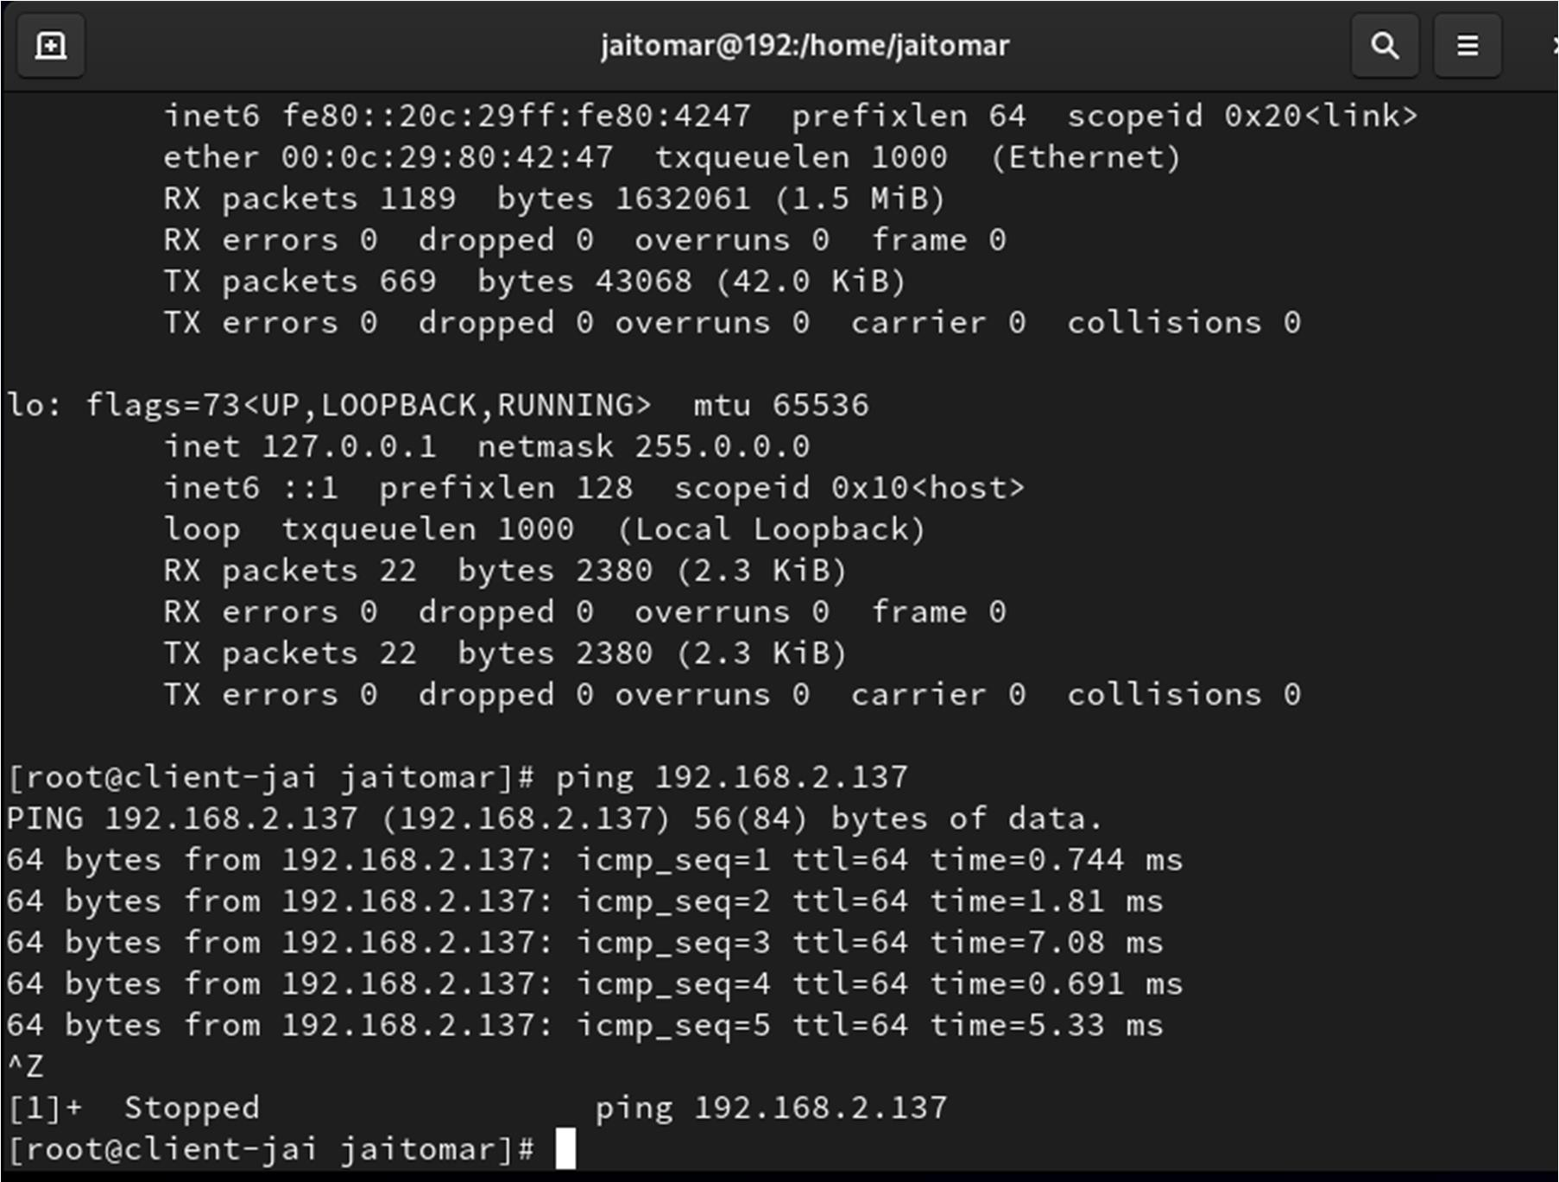

Successfully, both machines ping to one another. Stop communication by ctrl+z

Install the repository of SSH by using ( yum install openssh* -y ) on server machine as shown below:

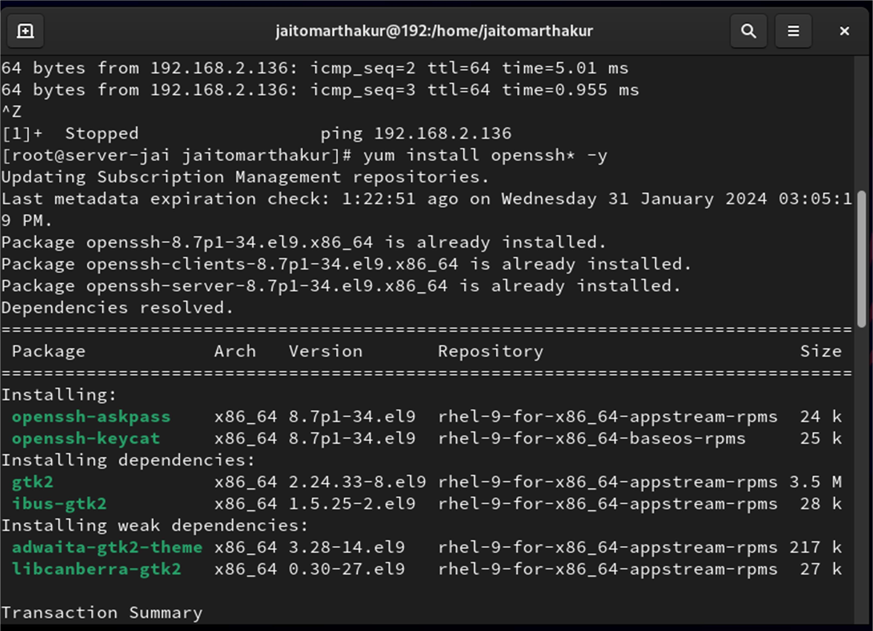

## Step 3 -

Installing openssh

Install the demon (services file) of SSH by using (yum install ssh* -y).

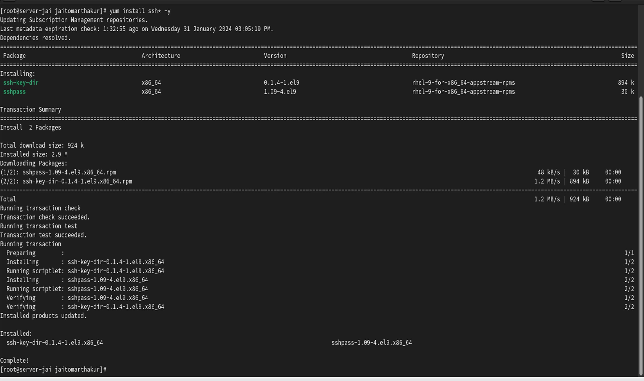

## Step 4 -

Go to the file and gave permission on server by using (vim/etc/ssh/sshd_config)

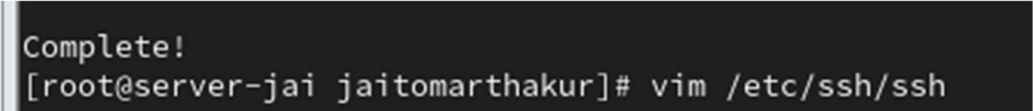

## Step 5 -

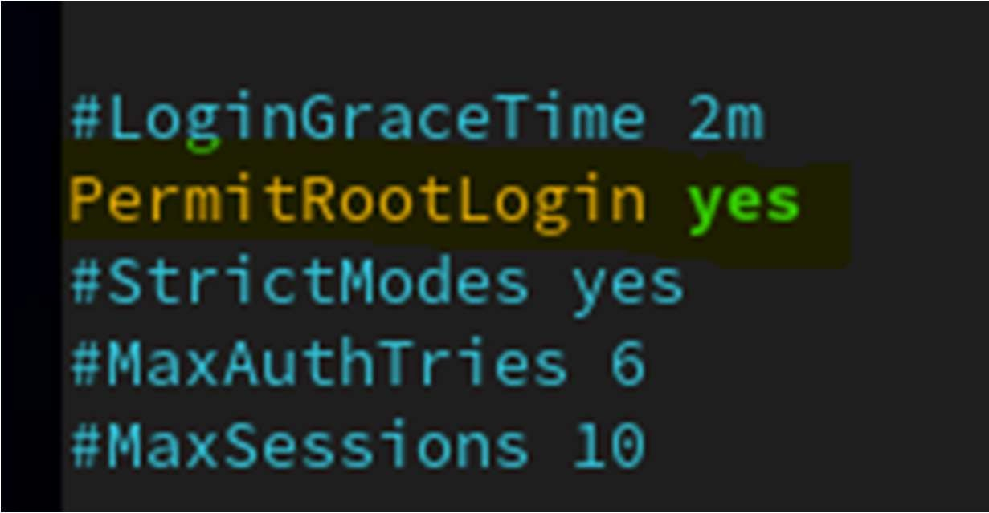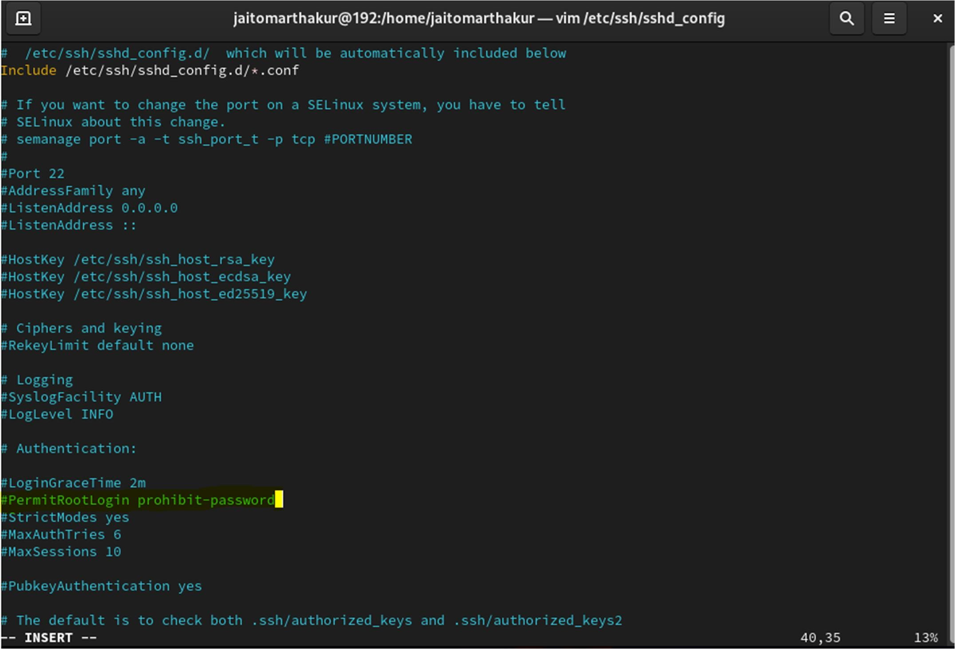Gave him permission to permitrootlogin yes

## Step 6 –

Now, restart sshd by using (systemctl restart sshd.services)

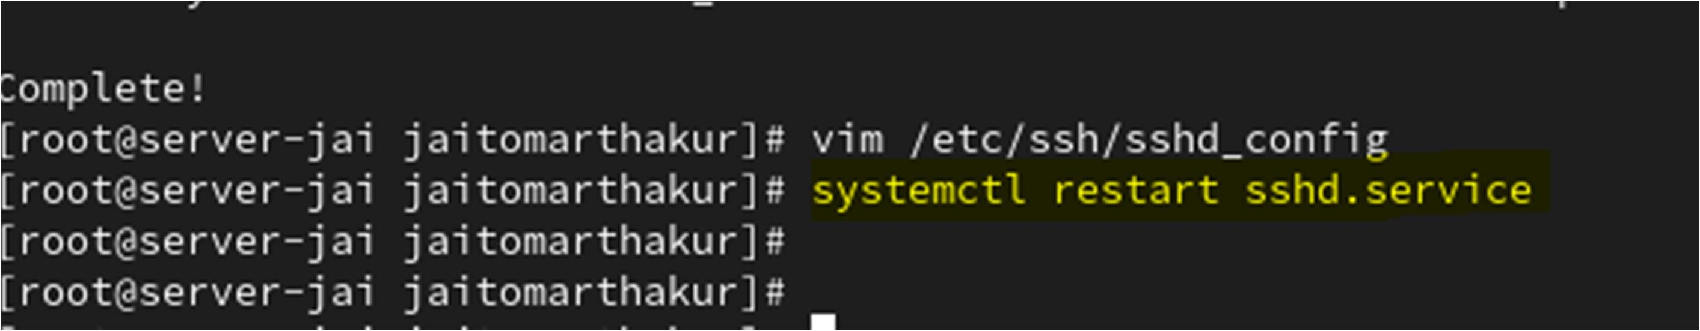

## Step 7 –

On client machine, Login server machine by using ssh and password (ssh [root@192.168.2.137)  IP on server machine.](mailto:root@192.168.2.137)

Then, type yes on fingerprint permission and input password of server machine.

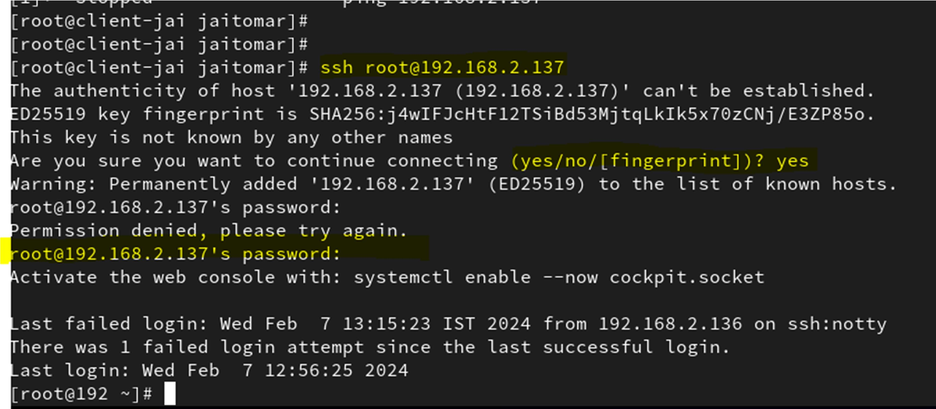

Client machine successfully accessing the server machine.

## Step 8 –

Generating Inscription key by using (ssh-keygen) on client machine.

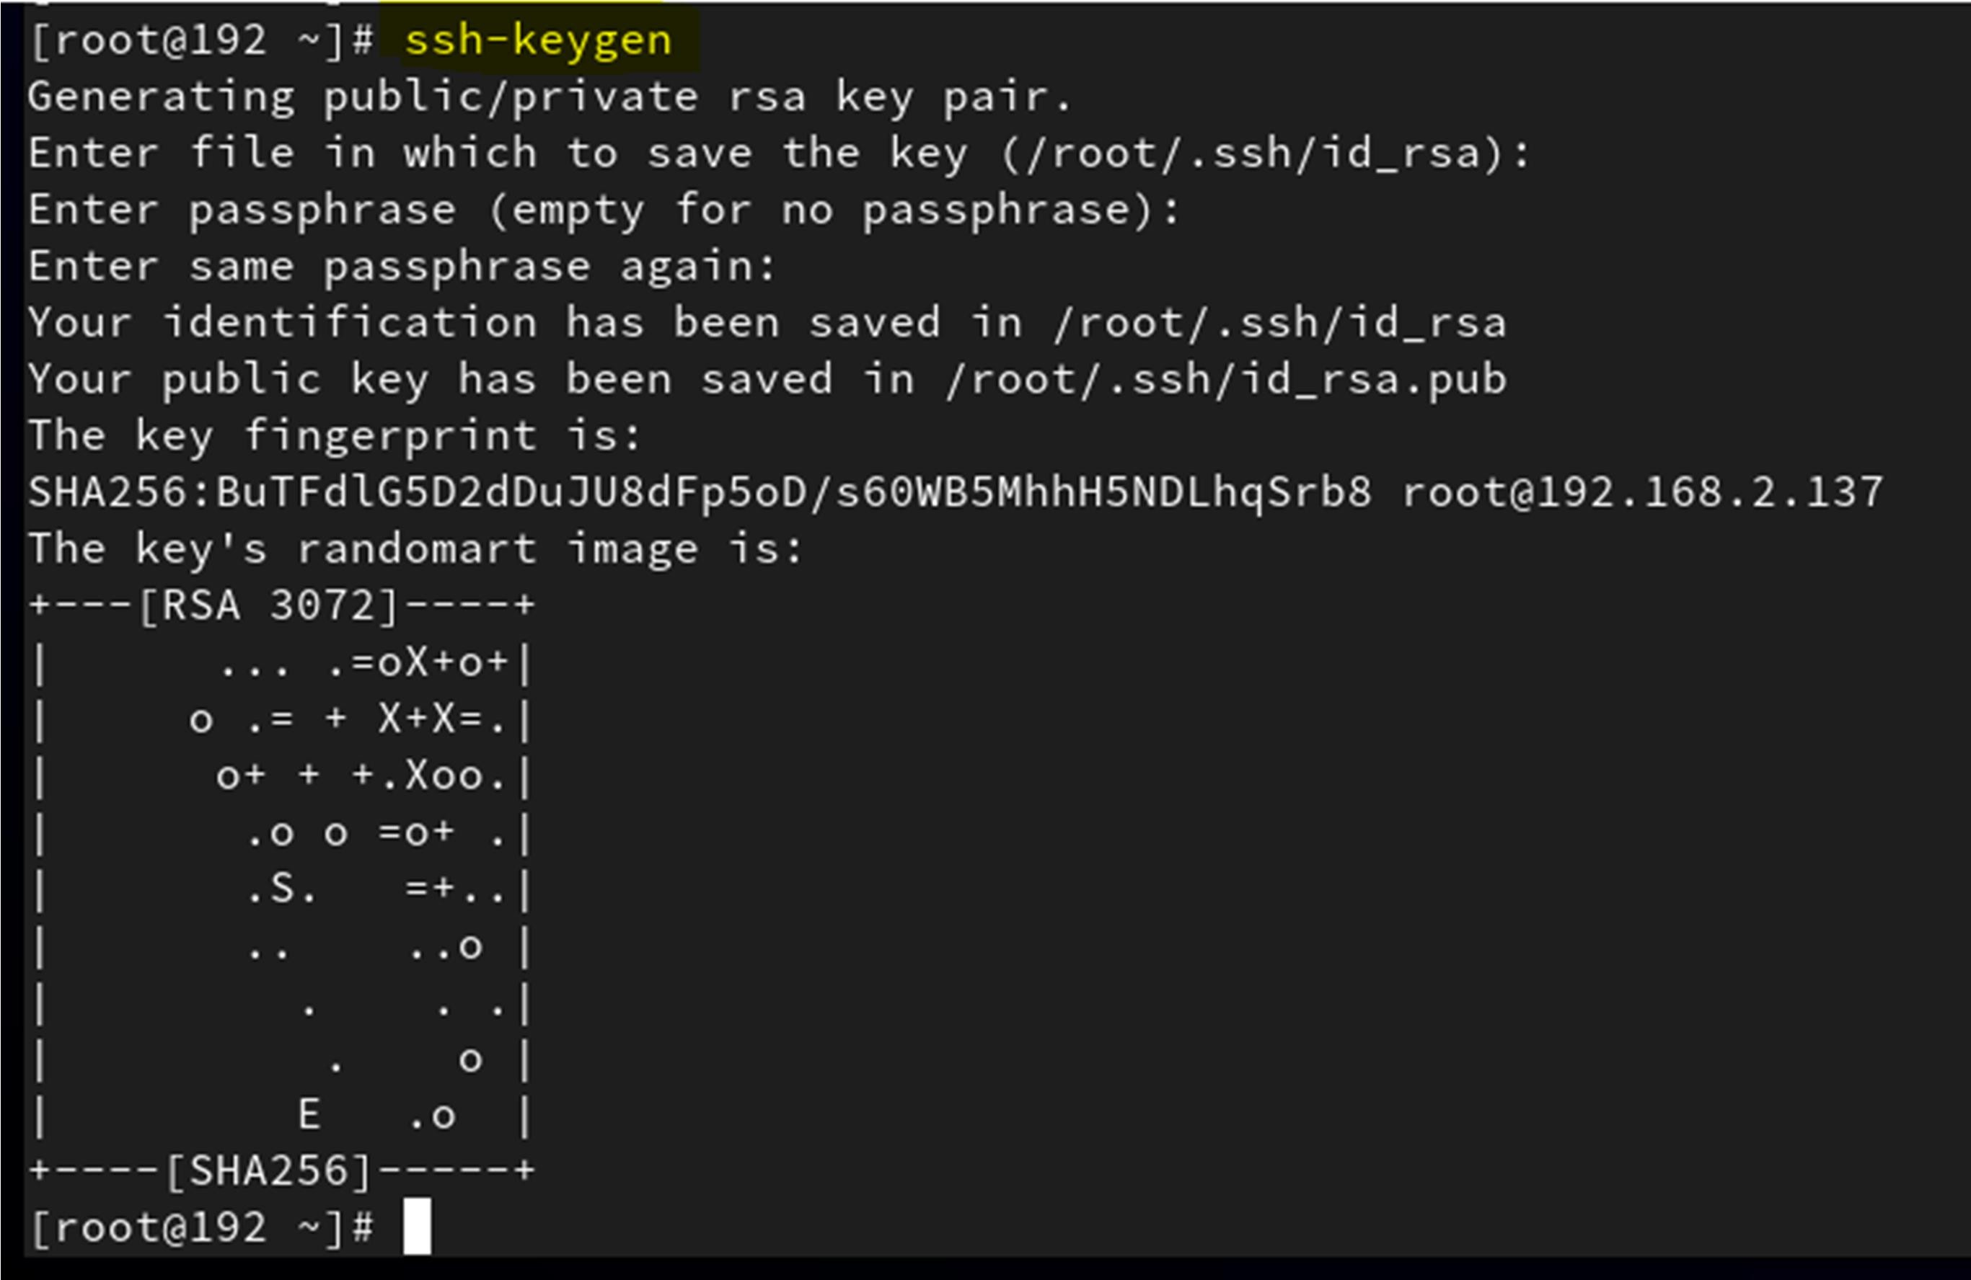

## Step 9 –

Copy SSH ID by using (ssh-copy-id [root@192.168.2.137)](mailto:root@192.168.2.137)

Then, give fingerprint permission yes and input password of server machine -

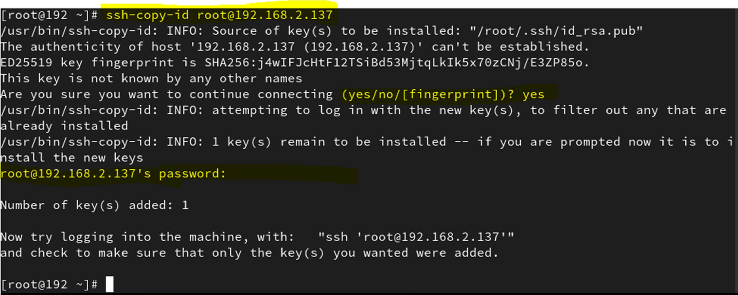

## Step 10 –

Login from ssh then connect without passwd By using (ssh [root@192.168.2.137)](mailto:root@192.168.2.137)